EX6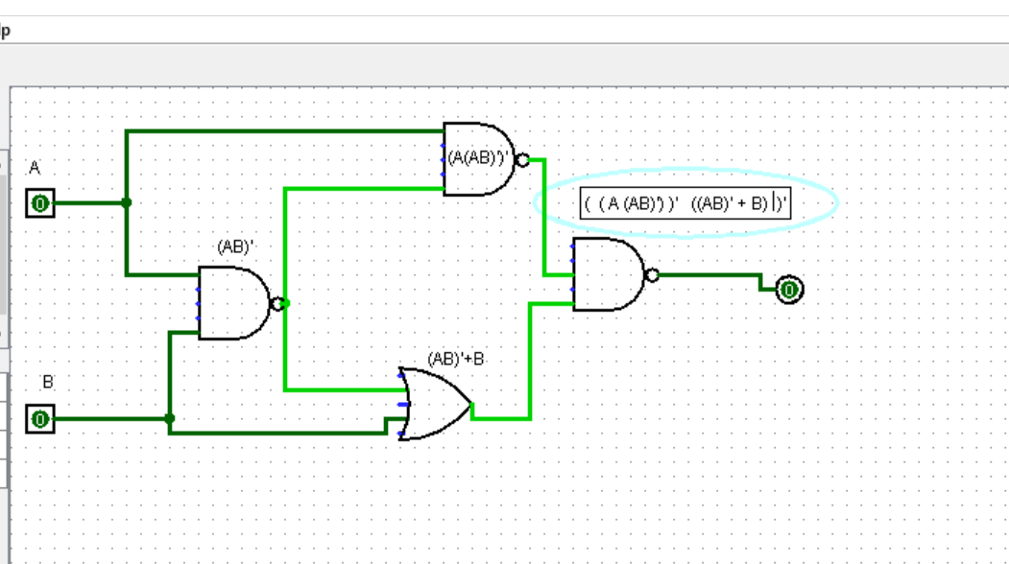

((A(AB)’)’ (AB)’B)’ BREAK THE BAR AND CHANGE THE SIGN

(A’’(AB)’ + (AB)’’B’ BREAK THE BAR AND CHANGE THE SIGN

(A’’(AB)’ + A’’+B’’B’ DOUBLE NEGATION LAW

(A’’(AB)’ + A+BB’ RULE 8

(A’’(AB)’ + A+0

(A’’(AB)’ + A BREAK THE BAR CHANGE THE SIGN

A’’A’+B’+A DM2

A’’A’B’+A

AB’+A

EX7

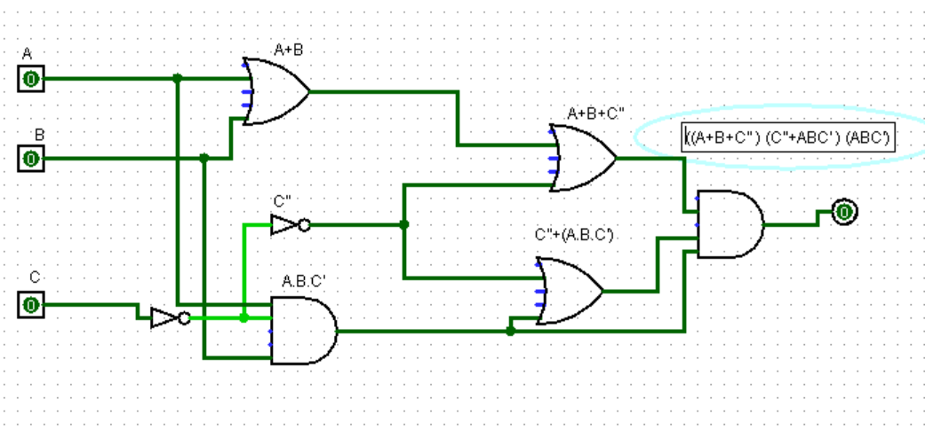

( (A+B+C’’) (C’’+ABC’) (ABC’) )

(A+B+C’’) (C’’+ABC’) (ABC’)

(A+B+C’’)C’’ABC’+(ABC’) NOT NOT RULE

(A+B+C’’) CABC’+(ABC’) Associative Law

(A+B+C’’) (AB)CC’+(ABC’) RULE 8

(A+B+C’’) (AB)0+(ABC’) NOT NOT

A+B+C (AB)0+(ABC’) ASSOCIATIVE LAW

A+B+ABC0+(ABC’) RULE 3

A+B+0+(ABC’) RULE 1

A+B+A(ABC’) COMMUNITIVE LAW

B+A+A(ABC’) RULE 5

B+AABC’RULE 7

B+ABC’ RULE 10

BC’